**r'^[0-9]{2}\s[0-9]{2}\s[0-9]{2}\s-\s[0-9]'**



**r'[0-9]{2}\s[0-9]{4}\s\-\s[0-9]'**

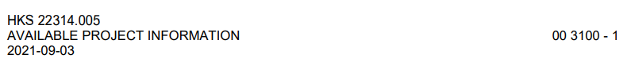

**r'^[0-9]{4}\-[0-9]{2}\-[0-9]{2}'**

Example 0000-01-01

**r'^[0-9]{2}\s[0-9]{2}\s[0-9]{2}'**

Example 11 11 11

**r'[0-9]{2}\s[0-9]{2}\s[0-9]{2}\s\-\s[0-9]'**

Example 11 11 11 – 01

**r'^\| '**

Example | Table Of Content |

Remove End Of Section

Remove End Of Document

Remove Empty Lines

Remove Extra Lines Coming From Closeout